1. **Explain Life cycle in Class Component and functional component with Hooks**

A [React](https://reactjs.org/?ref=retool-blog.ghost.io) component undergoes three different phases in its lifecycle, including mounting, updating, and unmounting. Each phase has specific methods responsible for a particular stage in a component's lifecycle.

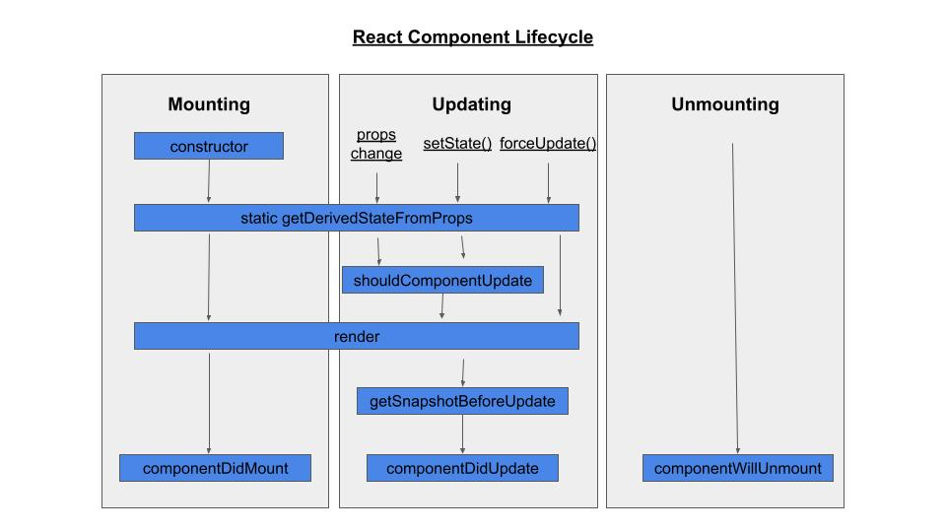**Phases of a React component's lifecycle**

A React component undergoes three phases in its lifecycle: mounting, updating, and unmounting.

1. The *mounting phase* is when a new component is created and inserted into the DOM or, in other words, when the life of a component begins. This can only happen once, and is often called “initial render.”
2. The *updating phase* is when the component updates or re-renders. This reaction is triggered when the props are updated or when the state is updated. This phase can occur multiple times, which is kind of the point of React.
3. The last phase within a component's lifecycle is the *unmounting phase*, when the component is removed from the DOM.